B.H.E.L.
A BRIEF OVERVIEW
IntroductioN

Bharat Heavy Electricals Limited is a giant public sector having a strength of more than 52,000 employees in various units in different strategic places, manufactures power generating equipment catering to 80% of the power requirements of our Nation. It manufactures various equipments related to fields like power, steel, fertilizers, textiles, cements, paper and pulp, oil and gas exploration, and transportation.

BHEL was set up primarily to meet the needs of the power sector in the country. The plant was established nearly 40 years ago at Bhopal and this was the genesis of the Heavy Electrical Equipment Industry in India. BHEL is today the largest engineering enterprise of its kind in India, with excellent track record of performance making profits continuously since 1971-72. It has achieved a sales turnover of Rs. 5755 cr with a profit before tax of Rs. 864 cr in 1996-97.

Today BHEL has 14 Manufacturing Divisions, 9 Service Centres and 4 Power Sectors Regional Centres, in addition to over 150 project sites spread all over India and abroad to provide prompt and effective service to customers.

The manufacturing units are located at Bangalore (2 units), Bhopal, Govinwal, Haridwar, Hyderabad, Rudrapur, Jagadishpur, Jhansi, Ranipet and Tiruchirapally (2 units). The service centres are located at Bangalore, Baroda, Calcutta, Chandigarh, Secunderabad, New Delhi, Nagpur, Patna and Varanasi. The power sites are located at various places spread across the country.

BHEL CORPORATE PRODUCT PROFILE :

HYDERABAD : Up to 250MW Gas Turbines,
Steam Turbines, Compressors, Electrical Generators, Circuit Breakers,
Pumps, Heat Exchangers, Oil rigs and Bowl Mills.

HARIDWAR : Up to 500MW Hydro Turbine

RANIPUR : Casting, Forgings

TIRUCHIRAPALLI : High Pressure Boilers & Valves

RANIPET : Boiler auxillaries

BHOPAL : Up to 200MW Generator Motors

JHANSI : Transformers

BANGALORE : Control Equipment

BANGALORE : Electroporcelain Equipment

GURGAON : Solar Energy Centre

JAGADISHPUR : Electrical Insulators

VARANASI : Repair Centre

GOVINDWAL : Valves

RUDRAPUR : Fabrication

MUMBAI : Repair Centre

CHENNAI : Piping

HISTORY OF HPEP UNIT :

The Hyderabad unit of BHEL was inaugurated by Shri Lal Bahadur Sastri in 1963. The unit has started its Turbine Manufacturing activities with the collaboration of Czechoslovakia for 110MW and 60MW Turbines and Generators in 1965. BHEL Hyderabad has started manufacturing Gas Turbines from 1990 and has various critical components that require very highly reliable and sophisticated machinery and also testing facilities.

PRODUCTS AND PROCESSES :

1. Turbines and Compressor Shop
- Steam Turbines and Compressors
- Gas Turbines and Compressors
2. Turbo Generators
- Steam Turbine Generators
- Gas Turbine Generators

3. Switch Gears

4. Ferrous Foundry

5. Non-Ferrous Foundry

6. Heat Exchangers

7. Tool Room

8. Heat Treatment

9. Pattern Shop

10. Spares Manufacturing

11. Coal Pulverizers

12. Pumps

13. Oil Field Equipment ( Oil Rigs )

PRODUCT AND COLLABORATION :

Industrial Turbines Siemens-West Germany

Marine Turbines English Electric Co. UK

Oil Rigs V.S.S. Engineers and Consultant USA

Switch Gears ASEA Sweden Turbo Hydra sets Motor

Feed Pumps Proma Sheaport USSR

MAIN SHOPS IN BHEL HYDERABAD UNIT :

- 01 SHOP : Steam Turbines and Compressors Shop

It is the biggest shop floor with plinth area of 35,311 sq-m ( approximately accommodating 1000 people ). It contains nearly 250 machines. The products are

1. Steam Turbines :
- Utility Sets 60,110,120 KW
- Industrial Sets 1.5 to 60 MW

2. Gas Turbines :

- Frame – 3 10.8 MW
- Frame – 5 25.26 MW
- Frame – 6 38.4 MW
- Frame – 9 110 MW
- Frame – 9 FA 250 MW

3. Compressors :
- Centrifugal Compressors
- Horizontal and Vertical Split Type

- 02 SHOP : Electrical Machines ( Turbo Generators )

    - Turbo Generators of capacity 1.5 MW to 210 MW and 500 MW
    - Synchronous condenser
    - Exciters
    - BFP Motor ( Boiler Feed Pump )
    - Alternators

- 03 SHOP : Switch Gear

- Breakers
- Air blast circuit breaker
- Minimum oil circuit breaker
- Sulphur hexa fluoride gas breaker

- Fuel nozzles for gas turbines

- Delta panel bowl mills

- Control panel for electrical machines

- Plasma coating showds for turbines

- 04 SHOP : Ferrous Foundry

All ferrous castings required for plant production products and casting of mill bases are casted in this shop.

- 05 SHOP : Non-Ferrous Foundry

All non-ferrous ( Aluminium & Copper ) casting required for the plant are manufactured in this shop.

- 06 SHOP : Heat Exchangers and Fabrications

Heat Exchangers Fabrications
- LP a)stator
Frames
Heaters b)Ball mills
Shells
- HP c)Foundations
Heaters
- De-aerators
- Ejectors
- Condensors

- 07 SHOP : Tool Room

Jigs and Fixtures

    - Single and multi point cutting tools
    - Press tools
    - Backing cone

- 08 SHOP : Common Work Shop

- Heat treatment, hardening, tempering, normalizing, stress relieving etc for surface treatment in this so that the following operations are done.
- Forgings
- Electro plating, pickling and timing etc.
- Babbitting

- 09 SHOP : Patter Shop

All patterns required for ferrous and non-Ferrous shops are manufactured in this shop.

- 10 SHOP : Spares Centre

    - Product Spares
    - Machine reconditioning centre
    - Rewinding Section
    - Refrigeration and Air Conditioning Section

- 51 BUILDING RIG UP YARD

      - Oil Field equipment – Hoisting & rotating equipment
      - Coal Pulverizers
          - Bowl Mills
          - Tube Mills ( Ball Mills )

Man power in this shop is 583, turnover for 1994-95 was 166 crores.

- 70 BUILDING PUMPS SHOP

        - Boiler Feed Pumps ( capacity 210 MW – 500 MW )
        - Condensate Pumps
        - Oil Pumps
        - Cooling Water Pumps

In keeping with the growing product profile introduction of complex technologies and international standards, BHEL has equipped its floor with advanced facilities and infrastructure that represents the program of R and D at its neighbouring facility to introduce better and more effective methods and processes all the time.
The unit has been divided into many divisions to facilitate the smooth production flow. Each division is self-contained with the personnel. Finance material management, Production and Commercial functions.

BHEL also got ISO 9001 Certificate from BVQI, in 1992-93.

BHEL in the Field of Transportation :

A high percentage of the trains operated by Indian Railways are equipped with BHEL’s traction control equipment including the metro at Kolkata. The company supplies 3900 broad gauge AC locomotives to Indian Railways and diesel shunting locomotives to various industries. 5000/4600 Hp. AC/DC locomotives developed and manufactured by BHEL has been leased to Indian Railways. Battery powered road vehicles are also manufactured by the company.

Non Conventional Energy Sources :

Technologies for exploiting non conventional and renewed sources of energy include wide generators, solar-power based pumps, lighting heating systems. BHEL manufactures large wind electric generators of unit rating up to 250 KW for wind turbines to meet the growing demands of energy. Desalination plants to help augment the supply of drinking water to people.

International Operations :

BHEL products, services and projects have been exported to 52 countries ranging from the United States in the West to New Zealand in the far East. The cumulative capacity of power generating equipment supplied by BHEL outside India is 3000 MW.

The company’s overseas presence includes several projects. A few notable ones are 150 MW (ISO) Gas Turbine to Germany. Open Cycle Gas Turbine Power Plant to Malaysia. Tripoli West Power Station in Libya executed on turnkey. Thermal Power Plant 150 MW (ISO) packages each to Malta & Cyprus. Heat Generators to New Zealand, and Hydro Power Plant to Thailand.

BHEL has recently executed major Gas based power projects in Saudi Arabia and Oman, a Boiler contract in Egypt and several Transformer contracts in Malaysia.

For outstanding performance in exports, BHEL won the Top Exporters Shield from EEPC for the year 1995-96 in the project explore category.

Technology Upgradation and Research & Development :

BHEL has upgraded its products and related technologies to contemporary levels through continued house efforts and acquisition of technology from leading engineering organisation in the world viz. Siemens, General Electric, GEC-Alsthom, Vogt-NEM, oto Melara, Nuovo Pignone, Asea-Brown Boveri Cei (ABB), Hitachi, TOA, National Oil Well VARCO etc.

BHEL Corporate R&D Centre at Hyderabad is supported by R & D Centers at each of the manufacturing divisions. Several state-of-the-art Technologies developed on the house have been commercialised like Fluidised Bed Combustion Boilers. Direct Ignition of Pulverised Coal ( DIPC ) etc. BHEL has also transferred technologies developed in the house including FBC boilers up to 15 tonnes per hour, Tungsten Carbide Thermowells, special welding electrodes etc. to Indian companies for commercialisation.

Human Resource & development :

The most prized asset of BHEL is its 62,000 employees. The Human Resource and Development Institute and other training institutes of the company help in not only keeping their skills updated and finally honed but also add new skills when they require continuous training and retraining. A positive work culture and participate style of management have led to the development of committed and motivated workforce and enhanced productivity and quality levels.

Information of technology process (tc&gt)

What is the quality policy of BHEL?

BHEL is committed to ensure quality of its products and services including compliance to statuatory/regulatory requirements through continual improvement leading to customer satisfaction and business growth.

What are the objectives of BHEL?

To ensure
    - Products/service quality by improving key processes.

    - Value addition by reading cost of quality

    - Customer satisfaction by improving delivery & response.

    - Quality of supplies by improving supplier performance.

    - Capability of human resources by upgrading skill and competence.

List the objectives of TC & GT technology department?

- To develop and issue technology process(including special process if any)as per design documentation and quality plan requirement to PPC within maximum period of 6weeks of receipt of documents from engineering.

- To develop and order jigs,fixtures and special tools drawings within 15 days after receipt of requisition from process planner.

- Issue of revised documents as per dca s issued by engineering as applicable within 5 days after receipt of dcvs.

- Issue of technological documents against ncr s issued q.c within days after receipt of engineering documentation.

- Amendments to process after issue of documents to shop to be minimum.

- Continual improvement in technological documents to shop to be minimum.

- Technology shall furnish estimated standard hours for new products within 2 weeks after receipt of information from engineering.

What is the general function of TC & GT?

- The main function of the technology department is to identify the proper technological process, establish, improve and maintain the process.

- This departmental procedure outlines various performed by the technology department of turbines, compressors and gas turbines (TC & GT) . this procedure also incorporates all the functional requirements envisaged in the quality assurance manual .

- Activates to be performed by technology department personnel which are not covered in this departmental procedure may b assigned by chif of TC & GT division.

- Head of technology (TC & GT)shall assign performance of duties and issue the organization chart (HY / ECH/TC and GT / ORG)accordingly.

- Each sectional head may delegate performance of duties to personnel in his section . However, retaining the overall responsibility.

What is the process planning ?

Process planning is to scrutinize the drawings for manufacturing feasibility and developing the sequence of operations in an economical way.

What are the functions of technology?

- Scrutiny of the engineering drawings for it manufacturing.

- Process Designing/operational sequence

- Identification of special tools,Jigs and Fixtures

- Designing of special tools

- Rate Fixing

- Updating of part list information through LAN to main frame

- Indenting of computer documents like wage cords,MSS

- Preparation of scope sub-contracts through terminals

- Indenting of material cards for RW & RJ parts

- Process designing for RW,RJ & NCR’s & issue to shop

- Establishment of process for new designs

- Establishment of process at sub-contractor’s works

- Association in procurement of machine tools

STEAM TURBINE

-  Turbines

The power generating turbo-machines decrease the head or energy level of the working fluids (like steam, gas, hydro and wind) passing through them. These machines are called turbines. They are coupled as prime movers to generators of power and running of pumps, compressors etc.

A stage of turbo machine generally consists of a ring of moving blades along with a ring of fixed blades. The principal element in a turbo machine stage is a rotor, which performs the basic function of transfer of energy. Thus a steam Turbine is a Turbo Machine.

A Steam Turbine is a turbo machine which is also an IC Engine to drive the generator section and a power conversion section. The gas generator section consists of a compressor, combustion chamber in which the gas is burned at a constant pressure and the next section is the turbine.

About Steam Turbine:

A Steam Turbine is a prime mover which converts heat energy into mechanical energy. in a conventional steam turbines cycle , water is used as the working fluid . The wart is heated in a boiler by burning fuel. It evaporates into steam which is expanded in a turbine where mechanical power is generated; the steam generated is of high temperature and high pressure. The temperature is often into 450 to 540degrees centigrade range. The pressure ranges between 60and 120 bar.

The essential parts of all steam turbines are similar, consisting of nozzles through which steam flows an expands (dropping in temperature and gaining kinetic energy) and the blades against which the swiftly moving steam exerts pressure. The blades are mounted on rotor drum, and an outer casing confines the steam to the steam to the turbine.

Both temperature and pressure fall as the steam passes through the turbine. The greater the pressure drop, the more energy can be captured from the steam. The more efficient power plants condense the steam back to water at the end of the turbine .

The theoretical maximum efficiency of a steam turbine based power plant is determined by the difference between the temperature at which steam enters the high pressure turbine and the temperature at which it exits the low pressure turbine. The greater the temperature difference, the more energy can be extracted.

Steam turbines are finding greater use in process industries (like steel and chemicals) producing large quantities of waste heat. The waste heat produced can be used to generate steam as well as power. The capital cost of such plants can be slightly higher but the generation of power represent s a useful by product when teh waste must be burnt in any case.

Steam turbines can also be deployed advantageously in industries with grater requirements of both steam and power. They are used in cogeneration or combined heat and power applications where process steam is also used in the turbine to generate electricity. This also results in substantial improvements in overall process efficiency.
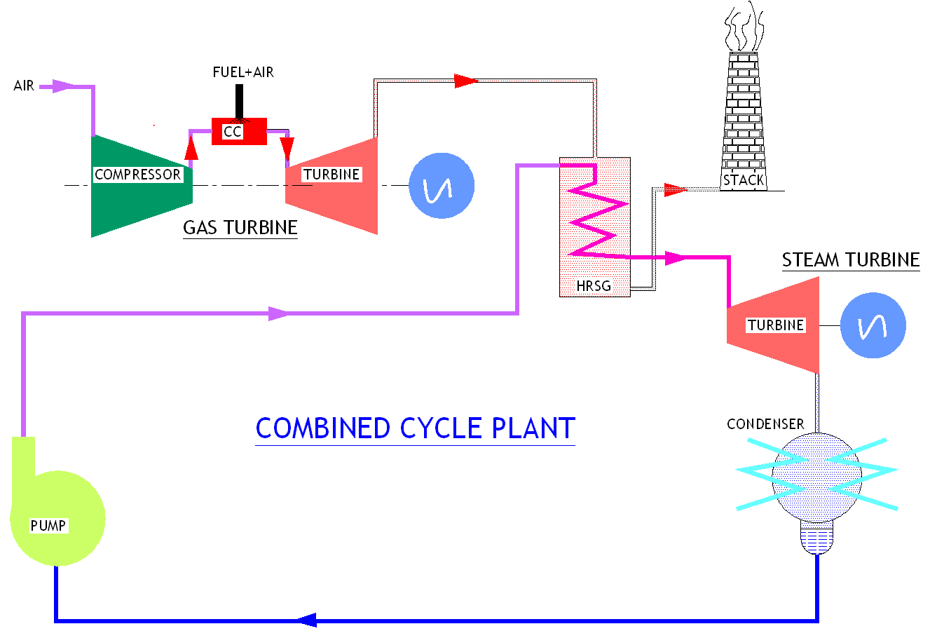

Towards higher efficiency
More efforts are being made to improve the efficiency of steam turbines. The areas are
  - Super critical technology advances aiming for 50 percent efficiency

  - Renovating and upgrading for more value for money

  - Combined heat and power for cost , more flexibility

  - Steam turbines in combined cycle, an new market

  - Clean coal technologies FBC, PFBC, IGCC etc to improve the overall efficiency and to reduce the pollution level.

Compounding of steam turbines

Steam jet does maximum work with good economy whenthe blade speed is just half the steam speed . due to very large rate of expansion , the steam leaves the nozzle at avery high velocity (supersonic , since the pressure ratio exceeds thecritical pressure ratio and the nozzle thus used is converging -diverging) of about 1000m/sec. Even though the rotor diameters are kept fairly small the rotatonal speed of 30000rpm may be obtained . such high speeds can be used to drive the machines only with a large reduction gearing arrangements. In actual de –laval turbine the velocity of steam leaving the blade is also quite appreciable resulting in energy loss.This amount to as high as 10-12 percent of the steam.

One of the chief object in the development of steam turbines is to reduce the high rotational speed of the rotor to practical limits.Several methods are used to reduce this high rotor speed by absorbing steam pressure or steam velocity in stages as it flows over the rotor blades. This is known as compounding .

Types of compounding
1. Velocity compounding (Curtis principle)
2.Pressure compounding
3. Mixed compounding
Impulse steam turbine
In impulse steam turbine , the overall transformation of heat into mechanical work is accomplished in two distinct steps. The available energy of steam is first changed in to kinetic energy and this kinetic energy is then transformed in to mechanical work.

A nozzle is a passage of varying cross section area in which the potential energy of the steam is converted in to kinetic energy. The increase of velocity of the steam jet at ateh exit of the nozzle is obtained due to decrease in total heat content of energy with minimum loss.
To overcome the feasibility of manufacturing convergent and divergent profile, the nozzle is made in two parts and passage between two adjacent blades is nozzle shape.

When the steam flows through a suitably shaped nozzle from zone of high pressure to one at low pressure its velocity and specific volume will both increase.

The equation of continuity
W=AV/v
Where w=mass flow in kg/sec
V=velocity of steam inm/sec
A=area of cross section insq m
v=specific volume in cubic m/kg
The method of velocity staging is known as Curtis principle.

Classification of Steam Turbines
1.Based on Blading Design
a) Impulse turbine
b) Reaction turbine
c) Combination of Impulse & Reaction turbine

2.Based on Application
a) Utility turbines
b) Industrial turbines
c) Nuclear turbines
d) Marine turbines
a) Utility Turbines
- Regenerative feed heating
- Regenerative feed heating with Reheat
- Combined cycle plants

b) Industrial Turbines
  - Captive Power plant
- Straight Condensing
- Straight Condensing with Injection
  - Co-generation Power Plant (Power + Steam to process)
- Straight Back Pressure
- Extraction Condensing
- Extraction Back Pressure
- Double Extraction Back Pressure/ Condensing
- Extraction / Injection
  - Drive Turbines
- Compressor drive
- Blowers drive
- Boiler feed pump drive, etc.
TYPES OF STEAM TURBINES
- Impulse & Reaction
- Industrial & Utility
- Single stage & Multi stage
- Single cylinder & Multi cylinder
- Reheat & Non-reheat
- Back pressure & Condensing
- Controlled & Uncontrolled Extractions of Steam
- Geared & Direct drive
- Barrel & Split Outer Casings
- Single & Double flow
- -2 Series
Maximum Inlet Parameters: 80ata/510 deg.C
Power Range: Upto 20 MW
Fixed Frame sizes
Back pressure, condensing with/without extractions 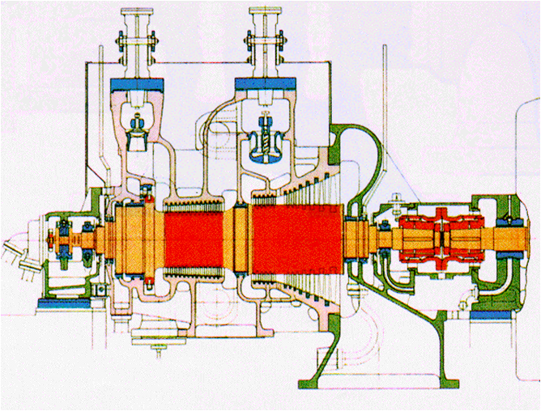
FIG:-2 SERIES turbine

- -3 Series
Inlet Parameters upto 140bar/540deg.C
Power Range upto 40MW
Building block principle
Two inlet sections “N” and “H”
Back pressure, condensing with/without extractions

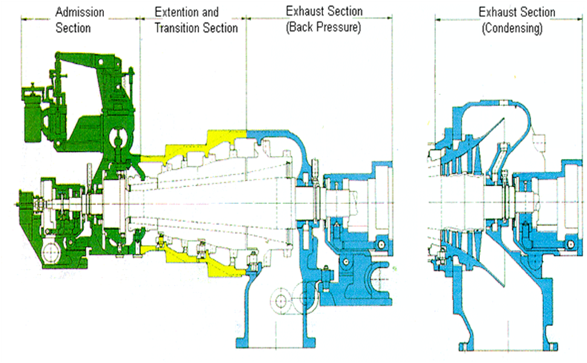
FIG:-3 Series Turbine

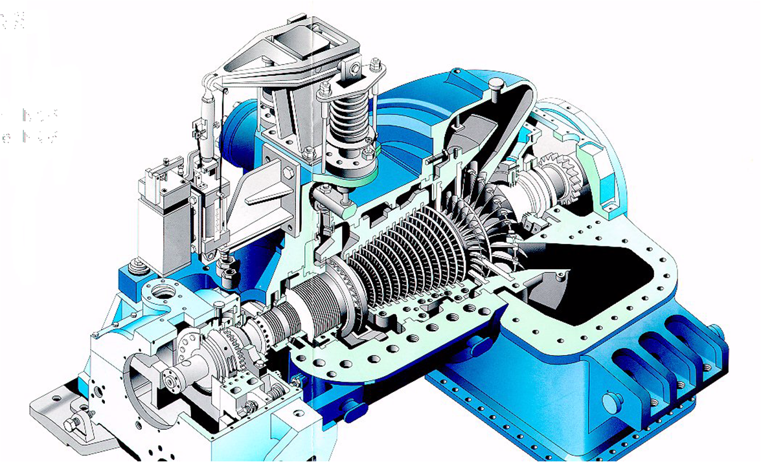
FIG:-3 Series Straight Condensing Turbine

- -4 Series

- Supplement to -3 series and larger capacities
- Inlet parameters upto 140 ata/540 deg. C
- Building block principle, centre admission, reverse flow
- Upto 80 to 100 MW, Non reheat
- Back pressure, condensing with/without extractions

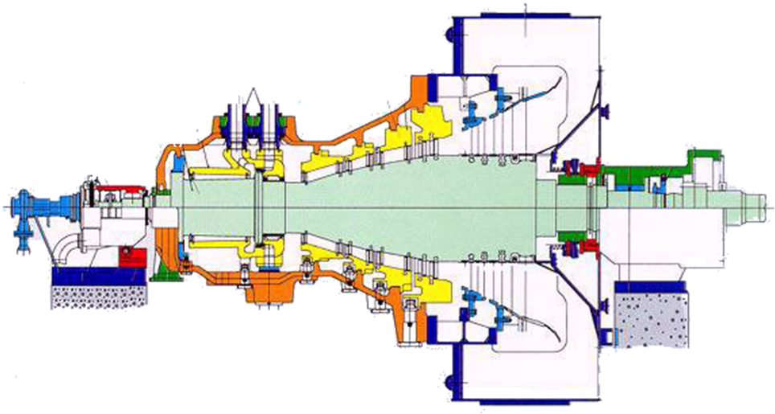
FIG:-4 SERIES TURBINE

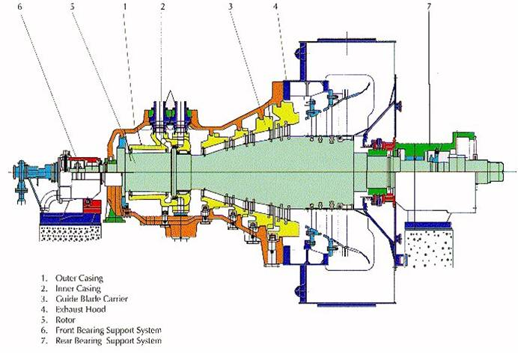
FIG:-4 SERIES TURBINE

- HNK90/5-4 turbine
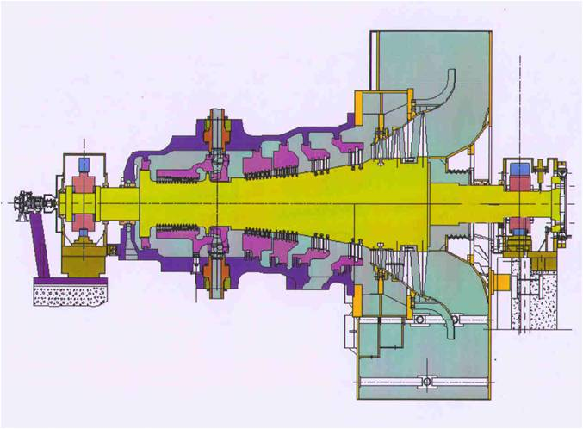
FEATURES:

-Basic Design in line with -4 series
- Largest Single Cylinder non reheat,regenerative module for 70-100MW
-Suitable for integration with advanced class GTs for CCPs
-Jointly developed 5sq.m exhaust hood,new front and rear bearing pedestal

- KN Series
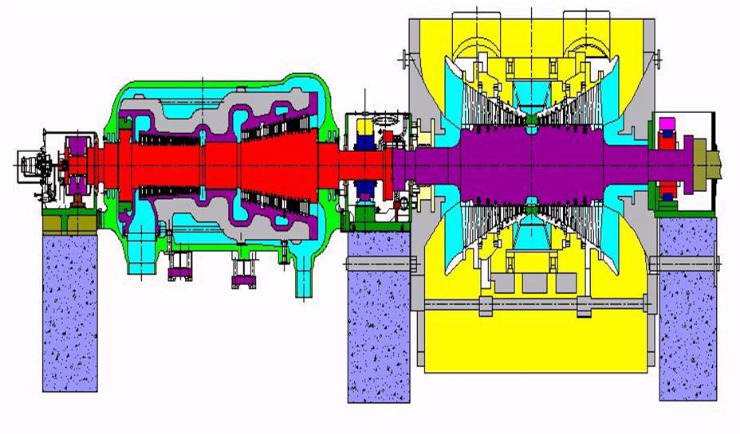
FIG:KN SERIES TURBINE

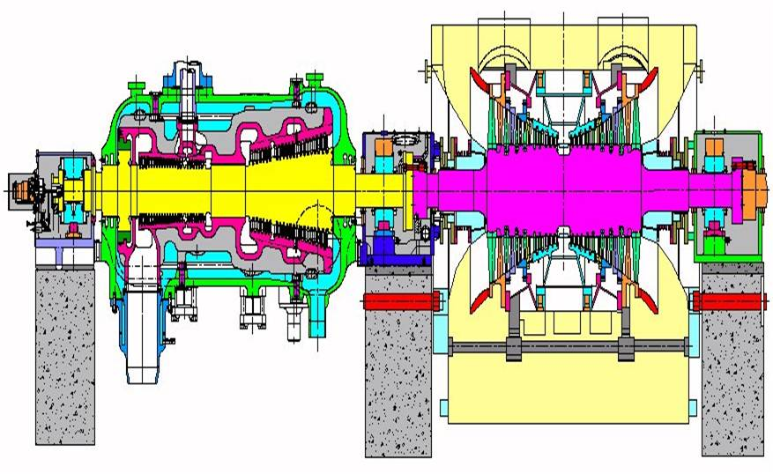
FIG:K30-16+N30-2*3.2 WITH OVERLOAD BY PASS VALVE

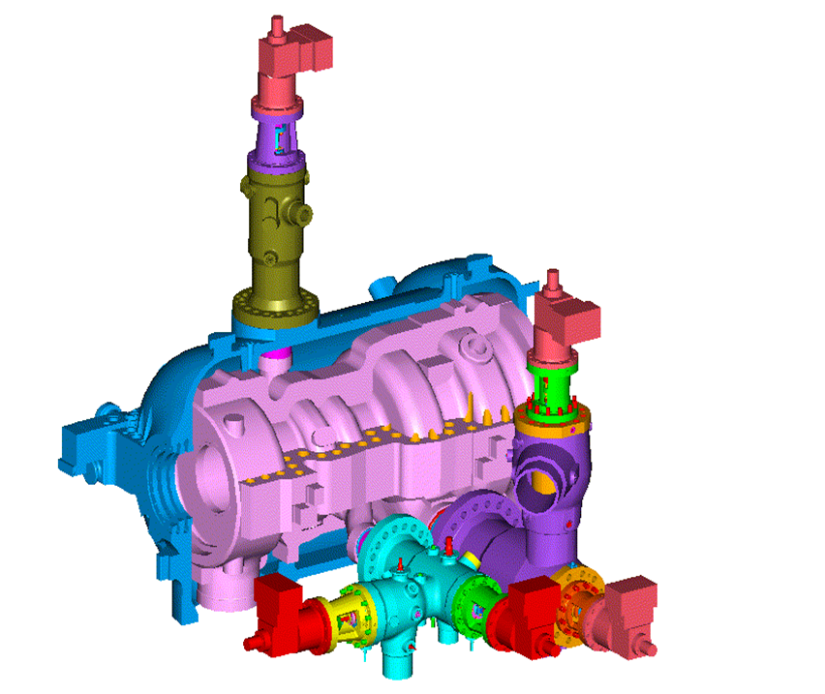
FIG:K30-16 TURBINE WITH OVERLOAD VALVE

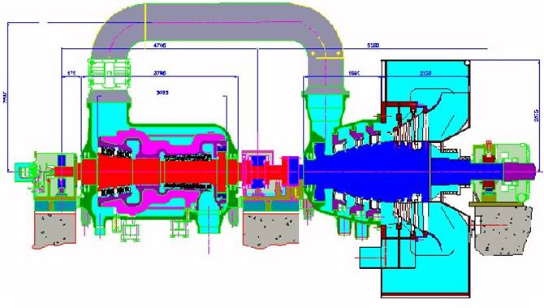
FIG:K30-16s+n30-1*5sq.m turbine

SIEMENS DESIGN
-2 SERIES (eg. K800-2 ,EK 1101-2,G400-2)
-3 SERIES (eg. ENK 32/45 -3,EHNK 50/56 -3)
-4 SERIES (eg. HNK 71/2.8 -4,HNK 71/3.2 -4)
KWU DESIGN
-HMN SERIES(eg. H-30+M-30+N30-2X3.2)
-KN SERIES (eg. K30-16,N30-2X3.2)
BHEL DESIGN
NEW SERIES TURBINES

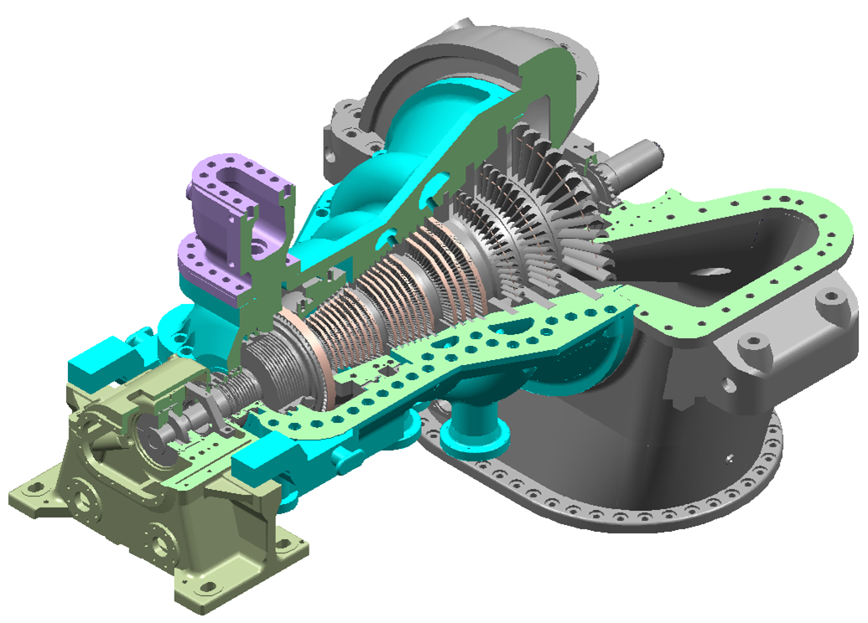
The parts of steam turbine
1.Rotor
2.Casing
3.Steam chest
4.Bearings
5.Coupling
6.Glands
7.Emergency stop valve
8.Control valves
9.Servo motor
10.Governing system
11.Turning gear
12.Vibration probes

Rotor
The rotor is the rotating part of the turbine, the blading serves for converting the thermal energy of the steam in to mechanical energy, the turbine rotor, as carrier of blades, transmits the mechanical energy impulses on the running blades in eh form of rotational energy to the driven machinery,
It rotors are made of forging of alloy steel material . the moving blades are mounted in the grooves made on the rotor. The turbine utilizes moving and non –moving blades, non-moving blades are either attached directly to the turbine casing or else they are located in the carriers . Short strips of metal , shrouding, are attached to the outer edges of the non moving blades. This shrouding is used toe assist in maintaining rigidity of the blades. An impulse wheel at the admissioned of the rotor is equipped a different type of blading and serves as the regulation stage or impulse stage.
A tapped radial hole drilled into the stud of the front –bearing journal is intended for housing the over speed monitor, cams protruding from the protection against excessive axial displacement of the rotor, whenever such and inadmissible axial shift of the rotor occurs during the operation of the turbine ,either of the two cams will engage with the lever of the emergency tripping device and thus induce shutting off the steam supply.
A toothed wheel mounted by shrinking to the rear end of the rotor permits in connection with a mechanical barring gear slow turning of the rotor by hand in order to prevent warping .

Parts of steam turbine rotor
- Blading plan

- Front gland

- Front oil gland

- Rear gland

- Rear oil gland

- Front journal

- Rear journal
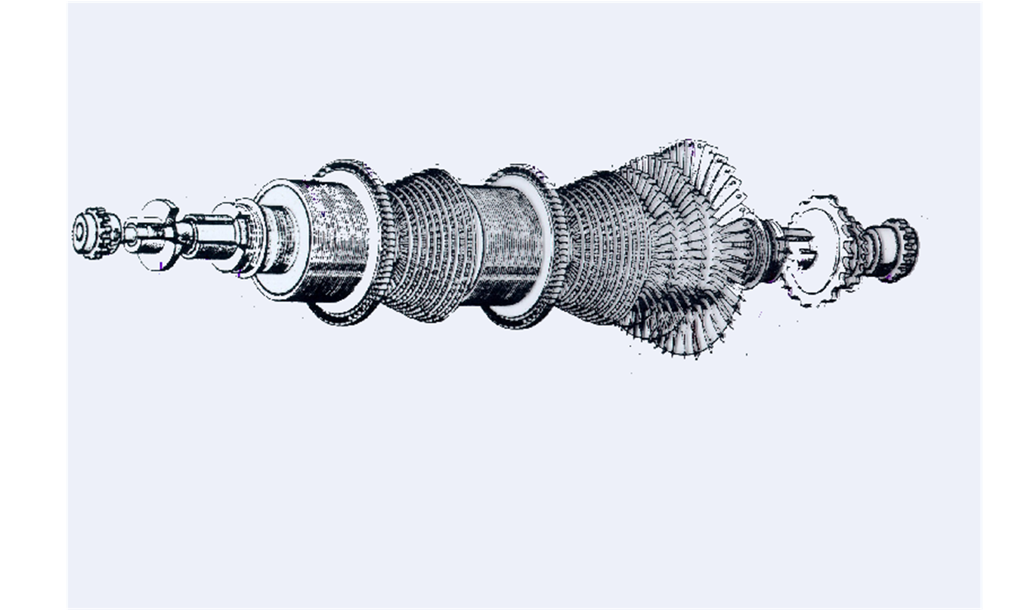
FIG:ASSeMBLED TURBINE ROTOR

SEQUENCe of operations for machining of rotor

Opn.No. | Description | machine
1. | Inspection of forging and verifying test certificates
2. | Inspecting dimensions of forging
3. | Face milling and Center drilling at both ends to facilitate loading on center lathe | HORIZONTAL BORING
4. | Program prooving | CENTER LATHE
5. | Turning the rotor from front to rear including journals ,thrust collars and flange partition and Turning T-blade grooves | CENTER LATHE
6. | Inspection
7. | Machining firtree grooves | CENTER LATHE
8. | Coupling flange hole drilling | CNC HORIZONTAL BORING
9. | Balancing holes drilling and lockway milling | CENTER LATHE
10. | Sealing fin caulking | Fitter
11. | Sealing fin Machining | CENTER LATHE
12. | HP Blades Assembly | Fitter
13. | Lock Blade drilling | HORIZONTAL BORING
14. | Lock Blade tapping | HORIZONTAL BORING
15. | Gland fin Assembly | Fitter
16. | Shroud Machining | CENTER LATHE
17. | LP Blades Assembly | Fitter
18. | Firtree Blade Assembly | Fitter
19. | Rotor Balancing | Balancing Machine

Casing
The turbine casing is made of cast steel and is split horizontally, the split being level with the rotor axis. The turbine casing houses and supports the turbine rotor, labyrinth seals, and bearings. The casing is cast in two halves and bolted together with a metal to metal fit. The casing of back pressure turbine is supported on separate bearing pedestals with the casing surface level with the rotor axis. This ensures the position of the casing relative to the rotor always remains constant at all operating temperatures. The radical blade clearances thus being unchanged. In order to permit unrestricted horizontal expansion of the casing without moving it out center.

The construction features of the two models in use are
-Horizontally split casing design
-Vertically split casing design

Horizontally split type design
The horizontal plane in the middle and consists of an upper and lower part. All necessary connections, such as suction and discharge nozzles, intermediate suction and discharge nozzles, wherever required, and lube oil inlet and drain connection are integral with the lower half. Internal parts can be accessed just by lifting the upper part which needs no major dismantling of piping . For inspection of bearings, there is no need to remove the upper half. Only bearing cover removal is adequate. The MCL, 2 MCL,3MCL and DMCL compressors are of horizontal split design.

Vertically split type design:
These are used when the working pressure and type of gas demand such and arrangement. The internal parts are similar to the horizontally split type casing, but the diaphragm seals and rotor bundle are inserted axially in a forged steel barrel casing. Ends are closed with end covers, the lower half of the bearing housing is integral with the end cover. By removing the end cover, it is possible to withdraw the complete internal assembly and have access to the internals like seals, diaphragms and rotor, without disturbing the outer casing. There is no need to remove end covers for bearing inspection .the BCL , 2BCL, DBCL, 3BCL, and PCL type casings are of the vertical split design.

 | SEQUENCE OF OPERATIONS FOR MACHINING OF OUTER CASING
Opn.No. | Description | W.P.
001 | General Information
002 | Inspection of the castings for the suitability of machine for both upper & lower parts. | QC Inspector
003 | Marking for both upper & lower parts. | Marker(fitter)
004 | Rough machining of PP, resting parts face milling & test pieces remover of LP. | H Boring
006 | Rough machining of PP, round bosses milling, face/ milling & test pieces removal of UP. | H Boring
010 | PP holes marking & tally marking for both UP & LP. | Marker
011 | PP holes drilling, spot face/ back counter bore & tapping of Upper part. | Radial drilling
013 | PP holes drilling, spot face/  Back counter bore & tapping of Lower part. | Radial drilling
015 | PP holes drilling & tapping of Upper part. | Radial drilling
019 | Reference diameters machining in Lower Part. | H Boring
022 | PP holes mis-matching checking & Assembly of both the parts for taper pin holes drilling. | Fitter
024 | Taper pin holes drilling & reaming. | Radial drilling
026 | Rough machining of connecting flange & rough machining of all blade grooves & skim cut on front gland bore in combined condition in the both UP & LP. | Homa VTL
030 | Rough machining of steam entry face & A wheel area machining in upper part only. | Homa VTL.
033 | Stress relieving both Upper & Lower parts after rough machining. | Stress relieving furnace.
035 | Parting plane finish machining of upper part. | H Boring
037 | Parting plane finish machining of lower part. | H Boring
041 | Colour matching by scraping & assembly both the parts. | Fitter
043 | Taper pin holes re-reaming | Radial drilling
045 | Connecting flange machining blade grooves finish machining without suspensions & skim cut on front gland bore. | Homa VTL.
049 | Finish m/cing of blade grooves  suspensions individually for both  the parts . | Homa VTL.
053 | Rough machining of front gland, BP gland, PT flanges butting faces & finish machining of steam entry face & A wheel area in combined condition. | H Boring
056 | Marking for peripheral milling for both upper & lower parts. | Marker
057 | Upper part peripheral machining/ milling i.e., valve chamber cover area with guide, diffuser bores, annular grooves, main steam inlet flange with oval groove, stop valve body with internal bores, front portion & top guide. | H Boring
061 | Lower part peripheral machining/ milling i.e., bottom flanges i.e gland steam connections flanges , BP flange, A wheel flange & front middle guide. | H Boring
065 | Marking for peripheral drilling & tapping for both upper & lower parts. | Marker
066 | Peripheral drilling & tapping of upper part i.e., valve chamber cover area, connecting flange holes. | Radial drilling
067 | Peripheral drilling & tapping of upper part by portable drilling i.e., monometer holes, pressure gauges holes, console flange holes, stop valve body & radial holes. | Portable drilling m/c
068 | Peripheral drilling & tapping of lower part i.e., bottom flange holes, connecting flange holes. | Radial drilling
069 | Peripheral drilling & tapping of lower part by portable drilling i.e., valve temperature measurement holes, blue matching holes & radial holes. | Portable drilling m/c
072 | HP valve chamber cover colour matching with outer casing upper part & assembly. | Fitter
074 | Hydraulic pressure testing both upper & lower parts in combined condition. | Fitter
076 | Grit Blasting of outer surface in assembled condition along with the valve chamber cover. | Grit Blasting closed chamber
078 | Painting at outer surface i.e., cast surface 15 Sq Mts. | Painting booth
080 | Taper pin drilling & reaming valve chamber cover & outer casing i.e., 1X Dia 20 h10 (1:50). | Radial drilling
082 | Reference dias machining on valve chamber cover with upper part. | H Boring
085 | Sealing fins caulking both upper & lower parts | Fitter
087 | Sealing fin dias machining of upper part | Homa 4mtrs VTL.
090 | Sealing fin dias machining of lower part | Homa 4mtrs VTL.
093 | Blade assembly in both upper & lower parts. | Fitter
094 | Tack welding & brazing of closing pieces for blade assembly. | Brazer
095 | Projections milling & Lock screws drilling for end blades of both upper & lower parts. | H Boring
098 | Colour matching of blade projections area. | fitter
100 | Assembly of both upper & lower parts. | Fitter
102 | Re-reaming of taper pin holes. | Radial drilling
103 | Finish machining of shroud dias. | Homa 4mtrs VTL.
107 | Finish machining of gland bores i.e., front & BP glands. | H Boring
111 | Assembly of diffusers in upper part | Fitter
112 | Welding of diffusers in upper part. | Welder
114 | Coupling of casing & exhaust hood & also colour match. | Fitter
116 | Cylindrical pin holes drilling & reaming for casing & exhaust hood both upper & lower parts in individually | H Boring
119 | Caulking & fixing of cylindrical fins in both upper & lower parts, scrape & match BP flange, inlet flange etc. | Fitter
122 | Finish machining of front & BP gland bores & rear steam gland at exhaust hood in combined condition for face outs & ovality corrections. | H Boring

3. STEAM CHEST:
The steam chest, located on the forward, upper half of the HP turbine casing, houses the throttle valve assembly. This is the area of the turbine where main stream first enters the turbine. The throttle valve assembly regulates the amount of steam entering g the turbine. After passing through the throttle valve, steam enters the nozzle block.

4. BEARING:
In order to support the weight of the turbine and to maintain radial and axial alignment, two different types of bearings are used.
- JOURNAL BEARING

Journal Bearing maintains the radical alignment of the turbine and supports the weight or the rotor. Bearings are spherically seated allowing for slight radial misalignment during installation only. They are located on the forward and rear end of turbine rotor. The bearings are internally lined with Babbitt, a metal alloy usually consisting of tin, Copper and antimony.

High pressure oil is injected into the bearings to provide lubrication. The oil is carefully filtered to remove solid particles.

- THRUST BEARING

Thrust bearing is located in the front end bearing pedestal, and is meant to take residual axial thrust present in the turbine which has not been eliminated by balance piston as well as to the maintain the axial position of the rotor in the casing.
The thrust bearing are double acting, segment shoe, kingsbury types, having the advantages of compactness and uniform pressure distribution on all the thrust pads.

5.COUPLING:
Flexible coupling: Transmits the torque from the turbines ato the reduction gears.The flexible couplings are designed so that any thrust created in the turbines will not be transmitted tothe reduction gears. They also allow for slight radial misalignment and provide a means of disconnecting the turbines from the main reduction gears.

6. GLANDS/SHAFT SEALS
The shaft seal on a turbine rotor consists of a series of ridges and grooves around the rotor and its housing which present a long, tortuous path for any steam leakage through the seal.
Glands with labyrinth seals are fitted at both ends where the shaft passes through the turbine casing. The labyrinth consists of sealing strips in the stationary part of the gland and grooves machined in the shaft. The labyrinth consists of sealing strips in the stationary part of the gland and grooves machined in the shaft. The leaking steam is collected and returned to a low-pressure part of the steam circuit.

7. EMERGENCY STOP VALVE
The emergency stop valve is the fundamental shut-off organ in the live steam line between steam generator and the turbine. The emergency stop valve is provided at the steam inlet to turbine. It is directly mounted on the casing with a view to reduce the quantity of steam entrapped between the stop valve and the control valves. In the event of sudden load throw off the more quantity of entrapped steam may tend to over speed the turbine. It will be in the closed position when the turbine is at standstill.
The emergency stop valve is equipped with a testing arrangement which permits checking of the valve spindle and piston rod for free movement at any time without interfering with normal turbine operation.

8. CONTROL VALVES
The control valve regulates the amount of steam flowing to the turbine according to the load. The cones of control valves are suspended from a beam. The beam is supported by two spindles which are raised and lowered through a system of levers by a servomotor arranged adjacent to the valves.
The hanging distance of each control valve is adjusted with reference to its valve seat on the beam, so that when the beam is lifted, the valves open in a sequences and steam is admitted progressively to the various nozzle groups.

9.SERVO MOTOR

10. GOVERNING SYSTEM
The most important and vital part of the steam turbine is governing system. The main purpose of the governing system is to maintain
-Constant speed at variable loads
-Constant speed at varying steam inlet parameters
-Constant speed at varying extractions and exhaust steam
PARAMETERS/CONDITIONS
The selection of Governors based on process requirements
-Speed/Frequency control
-Back pressure control
-Extraction pressure control
-Extraction back pressure control
-Boiler feed pump drive
The governing system should be simple in design, stable during operation and highly reliable. The governing system consists of a number of basic governing g elements and protection. The reliability and availability and availability of the equipment depends on the type of Governing System selected. The speed governing elements are the speed sensor governor with the proper transformer amplifier, servo motor and governing valves.

Types of Governors used on steam Turbines
  - Centrifugal fly weight governor(Mechanical governor)

  - Hydraulic governors
a) Hydro-Mechanical Governor
b) Hydro-Dynamic Governor
3. Electro-Hydraulic (Electronic Governor)
4. Electronic control
11. TURNING GEAR
Steam turbines are equipped with turning gear to rotate the turbine rotor after they have been shut down and while they are Collin. The evens out the temperature distribution around and turbines and prevents bowing of rotors.

12. VIBRATION PROBES
Steam turbines have sensors installed to measure the movement of the shafts in their bearings. This condition monitoring can identify many potential problems and allows the repair of the turbine to be planned before the problems become serious.

AUXILLARY EQUIPMENTS
DUPLEX FILTER
SOLENOID VALVE
TRIPPING DEVICE
TESTER OF OVER SPEED GOVERNOR
AUTOMATIC LOW LOAD LIMITIN G DEVICE
QUICK CLOSING NON-RETURN VALVE
LUBE OIL PRESSURE PROTECTION
EMERGENCY GOVBERNOR TESTING DEVICE
CHANGEOVER VALVE
STEAM JET AIR EJECTOR

Duplex Filter
Duplex filters occupy a unique position within the filter industry. They were created to enable operators to change contaminated filter elements without shutting down an active sysem.Duplex filters are popular for liquid and gas fuel applications.

Solenoid Valve
The solenoid valve is intended for installation in the pressure oil circuit to the automatic trip gear. When operated, it will interrupt the oil flow in that line. At the same time, the trip oil circuit will be connected to the oil drain where by emergency tripping is released. The solenoid valve is remote controlled electrically i.e it is either operated from the control room or by a protection device.

Tripping device
In the event of a disturbance, the emergency tripping devices serves for admitting emergency trip oil. This causes closing of the valves and separation of the turbine from the steam supply.

Design features of BHEL steam turbines
BHEL Hyderabad one of four major manufacturing units of BHEL family, is a pioneer in manufacturing of steam turbines in India. Steam turbines for whole range of applications like cogeneration , captive power , utility, drive and combined cycle plant applications are being manufactured under continuing technical collaboration with Siemens, Germany, BHEL is fully equipped to provide comprehensive solutions to customers, encompassing system engineering , turnkey erection and commissioning including civil works. BHEL, with over 38years of experience and over 540range, covering every possible type of application.
In industrial applications, production process and thus the steam parameters and flows decide the turbine selection . This makes each industrial turbine design an individual solution, with very special design features. BHEL has provided specific solutions with built –in reliability for a wide spectrum of industries using building block concept which is being continuously improved.

Range of capacities & Parameters of Steam Turbines:
The range of parameters cover wide spectrum encompassing all requirements of industry.
Power Up to 150 MW
Inlet pressure 4 ata to 140
Inlet Temp 140 °C to 540°
Exhaust Up to 55 ata
Condensing Up to 0.05 ata
Speeds 3000 RPM to 15000 RPM

Types of Steam turbines:

Extraction (E Series)
Back Pressure (G Series)
High Pressure (H Series)
ECM Rotor (M Series)
Condensing (K Series)
Low pressure (N Series)
Double flow (W series)
Extraction Back Pressure (EG Series)
Extraction Condensing (Ek Series)
Back pressure turbines (HG Series)
Double flow condensing (WK Series)

Special features of steam turbines:

- Building Block concept for optimum selection to suit any application

- Impulse/Reaction balding for better efficiency over a range of loads

- Individual design for optimum flow path

- Standardized components with proven service record for high reliability

- Electronic governing system

- Easy integration for cogeneration application

- Wide choice of power & speeds to meet any specific requirements

- Base frame design for smaller ratings

Diaphragms
The function of the diaphragm is
- To form the dynamic flow path of the gas inside the compressor

- To form the separation wall between one compressor stage and the subsequent one

- To convert the kinetic energy of the gas leaving the impeller into pressure energy.

They are of three types.
- Suction diaphragm

- Intermediate diaphragm

- Discharge diaphragm
The diaphragms are generally made of cast steel. However, based on operating conditions, alloyed cast iron, forged steel or stainless steel materials are also used , in small and medium size casings, the diaphragms are fabricated from plates.
Rotor
The basic function of the centrifugal compressor rotor is to impart the required compression energy to the gas.
The rotor forms the heart of the centrifugal compressor, consisting of the shaft, impellers, spacers, bushes, balancing drum, thrust collar, coupling hub and thrust bearing. The impellers are hot shrunk and keyed. The shrinking of impeller and balancing piston is necessary to ensure heat the impeller does to get slackened due to the centrifugal forces during start up and normal running of the compressor. This would otherwise result in vibrations on the rotor system. Rotor must perform its function with a deflection less than the minimum clearance between rotating and stationary parts. The loads involved are the torques, the parts, and axial gas forces. The rotor, during assembly is balanced stage wise.

Shaft
The shaft is made out of forged alloy steel and the impellers, spacers and the balancing drum are shrunk fitted on it . Spacers of stainless steel material are used to protect the shaft against gas erosion and corrosion, the shaft is made by turning and grinding operations, journal bearing zones of the shaft is ground and burnished with the diamond burnishing technique to improve the surface finish and to keep the total run outs within the permissible limits.

